1. Meng found that the unit for mangrove belowground biomass should be “g_m2” but not “gC_m2

” on Blanca’s datasheet (Text below from page 401).

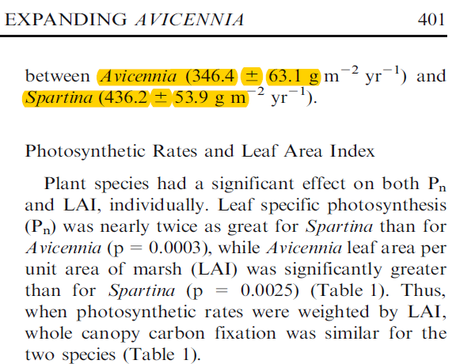

2. Soil C pool data were calculated from the bulk density and C%.

The paper does not report carbon density directly. We calculated carbon density from Table 2, which reported percent organic matter and bulk density, but not carbon concentration. To calculate carbon density, their data were entered into a spreadsheet, then processed with SAS code to calculate carbon density. The calculation steps were as follows:

a. Convert organic matter (OM) to organic carbon units.

We used the following equation developed by James Holmquist (in review):

SoilCC=0.074*(OM/100)*(OM/100) + 0.421*(OM/100) - 0.0080, where

SoilCC = C concentration in units of grams C per grams soil

OM = organic matter concentration in units of grams OM per grams soil

b. Convert soil carbon concentration (SoilCC) to carbon density.

SC=SoilCC*BD, where

SC=Soil carbon density in units of grams carbon per cubic centimeter (g/cm3)

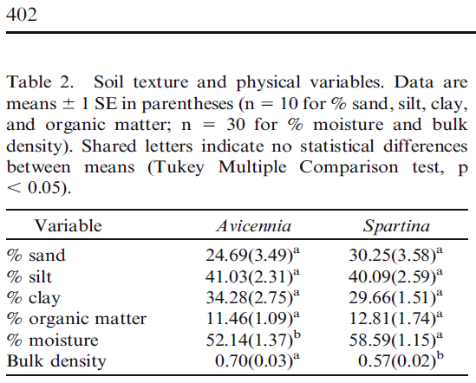

3. We can’t find the accretion rate from the PDF.

***[Response from Blanca]*** *From p. 5: decadal-scale accretion (5.3 and 5.8 mm yr-1) were similar between Avicennia and Spartina areas of the marsh; from table 2 you get %OM and BD. With these 3 pieces of information you can calculate gC/m2/y of both the way I explained before.*